Order of Operators - Questions
Key Stage 2: 2004 Paper A
1.
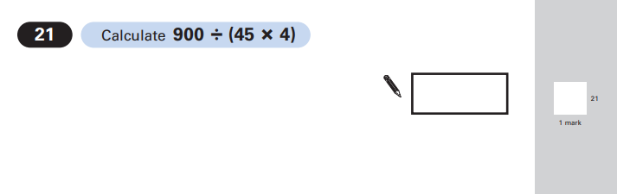
Key Stage 2: 2007 Paper B
1.
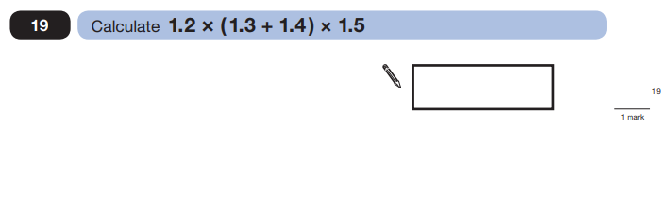
Key Stage 2: 2008 Paper B
1.
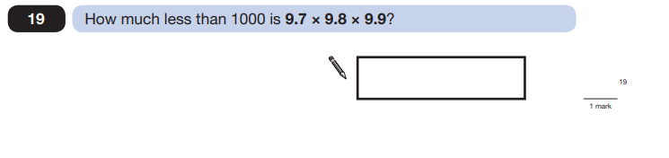

Key Stage 2: 2012 Paper B
1.
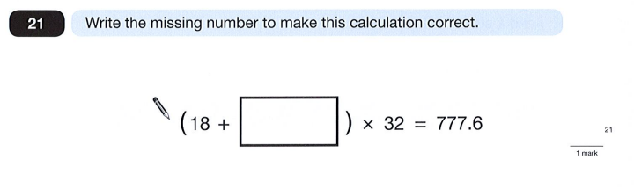
Key Stage 2: 2013 Paper B
1.
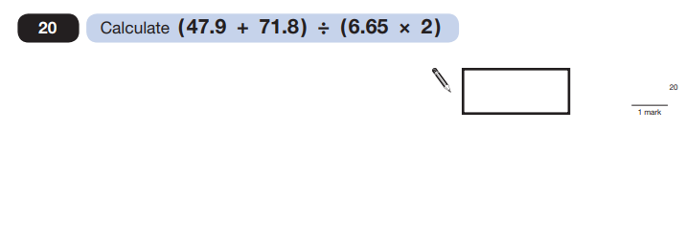

Key Stage 2: 2014 Paper A
1.
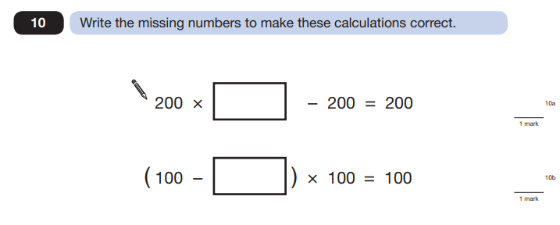
Key Stage 2: 2014 Paper B
1.
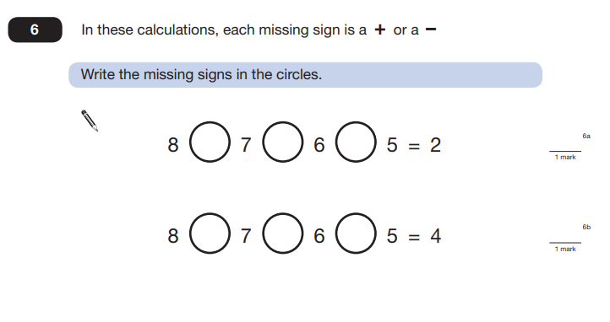

Key Stage 2: 2014 Paper B
2.
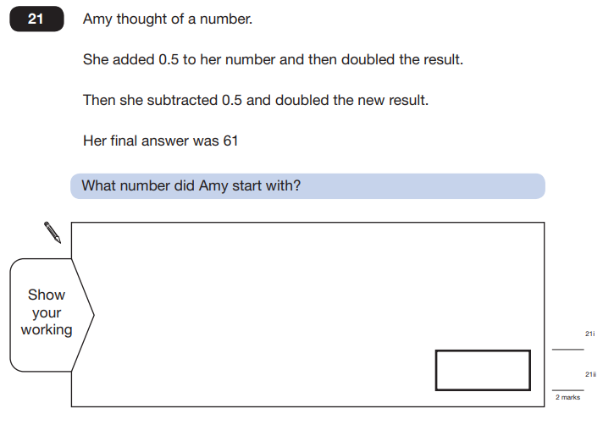

Key Stage 2: Paper 1 Arithmetic - Sample
1.
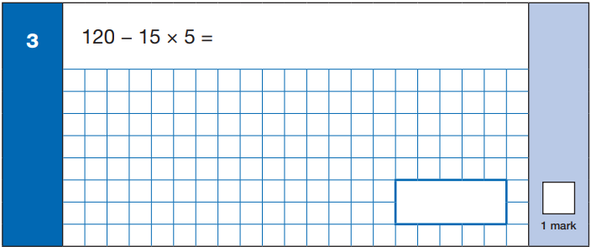
Key Stage 2: 2016 Paper 1 Arithmetic - Sample
1.
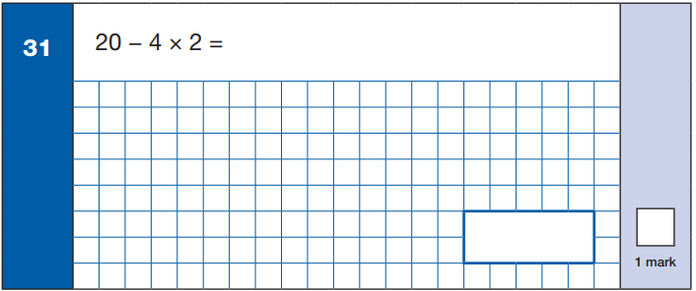

Key Stage 2: 2016 Paper 1 Arithmetic
1.
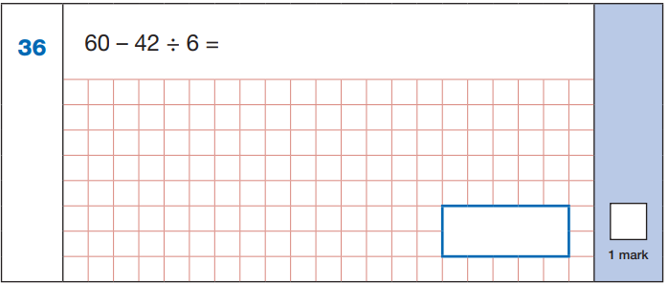
Key Stage 2: 2017 Paper 1 Arithmetic
1.
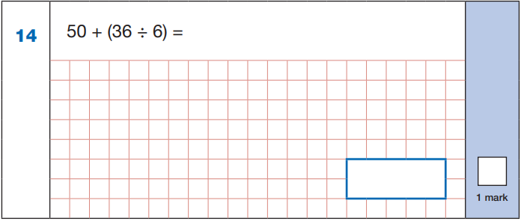

Key Stage 2: 2018 Paper 1 Arithmetic
1.
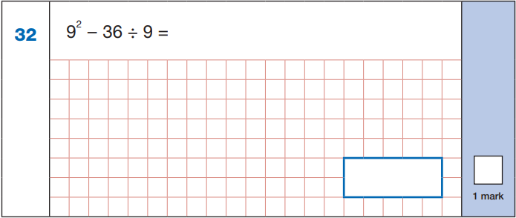
Key Stage 2: 2019 Paper 1 Arithmetic
1.
